

Tribhuvan University
Faculties of Management

“Laravel Developer Intern” AN INTERNSHIP REPORT

Submitted to
Department of Management
Himalaya Darshan College Biratnagar, Morang

In partial fulfillment of the requirement for the Bachelor in Information Management

Submitted By Name: Shibu Sharma
TU Registration No:7-2-1073-25-2021

Under the Supervision of Mr. Kushal Niroula

April 2026

Internship Certificate
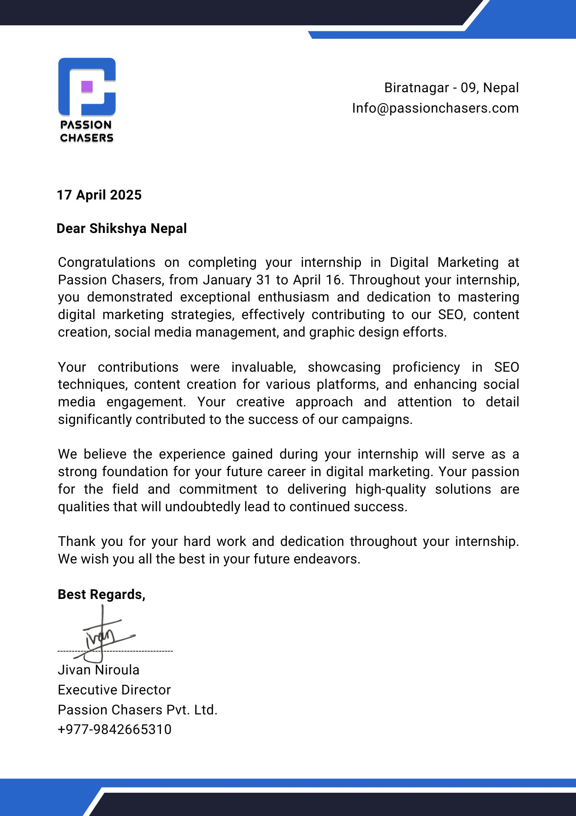

Mentor’s Recommendation

I now recommend that the internship report prepared under my mentorship by Mr. Shibu Sharma entitled “Laravel Developer Intern” as in partial fulfillment of the Bachelor of Information Management degree requirements be processed for evaluation.

...........................................................
Jivan Niroula
Mentor
Passion Chasers



Tribhuvan University
Faculty of Management
Himalaya Darshan College

Supervisor’s Recommendation

I at this moment recommend that this internship report is prepared under my supervision by Shibu Sharma entitled “Laravel Developer Intern” in partial fulfillment of the requirement for the Bachelor of Information Management degree be processed for the final evaluation.

…………………….
Mr. Kushal Niroula
Department of IT
Biratnagar-09



Tribhuvan University
Faculty of Management
Himalaya Darshan College

LETTER OF APPROVAL

This is to certify that this internship report prepared by Shibu Sharma in partial fulfillment of the requirements for the Bachelor of Information Management degree has been evaluated. In our opinion, it is satisfactory in the scope and quality of an internship report for the required degree.

Mr. Kushal Niroula  Internal Examiner, DoIT  Himalaya Darshan College | Er. Sumit Kumar Shah  HOD, DoIT  Himalaya Darshan College
...................................................................  External Examiner | Official Stamp

Acknowledgment
The internship program, required for the fulfillment of the 8th semester of the “Bachelor of Information Management” at Tribhuvan University, has provided me with an invaluable opportunity to cultivate technical skills, enhance my communication abilities, foster collaboration, and gain firsthand experience within the dynamic working environment of the IT sector.
I am grateful to Tribhuvan University and Himalaya Darshan College for allowing me to complete my 8th-semester internship as a part of my Bachelor of Information Management (BIM) degree. This internship has allowed me to learn technical skills, develop teamwork and communication abilities, and gain insight into real-world scenarios and working environments in the IT sector. I would like to express my sincere gratitude to Mr. Jivan Niroula, the Executive Director of Passion Chasers, for allowing me to intern at their organization. I want to express my deepest gratitude to my mentor, Mr. Jivan Niraula, a Senior Developer at Passion Chasers, for her guidance and support throughout my internship.

Abstract
As a Laravel Developer Intern, I successfully completed a three-month internship at Passion Chasers, located in Biratnagar-09, Nepal, as part of the academic requirements for the eighth semester of the Bachelor of Information Management (BIM) program under Tribhuvan University. This internship report summarizes the professional experiences, technical exposure, and practical skills gained during the internship period.
Throughout the internship, I was actively involved in multiple phases of web application development using the Laravel framework. My responsibilities included developing and maintaining backend functionalities, designing and integrating RESTful APIs, implementing authentication and authorization systems, and working with MySQL databases for efficient data storage and retrieval. Additionally, I contributed to debugging, testing, and optimizing application performance to ensure reliability and scalability. I also participated in front-end integration using HTML, CSS, JavaScript, and Tailwind to enhance user interface responsiveness and usability.
Working alongside experienced developers, I gained hands-on knowledge of Laravel MVC architecture, routing, middleware, migrations, Eloquent ORM, and version control tools such as Git. This internship improved my problem-solving ability, teamwork, and time management skills while providing real-world experience in developing secure and scalable web-based solutions. Overall, the internship strengthened my understanding of professional software development practices and increased my motivation to pursue a career as a Laravel Developer after graduation.
Keywords: Laravel Developer, Laravel Framework, Web Development, RESTful API, MySQL, MVC Architecture, Eloquent ORM, Authentication, Git, Backend Development.

Table of Contents

Internship Certificate ii
Mentor’s Recommendation iii
Supervisor’s Recommendation iv
LETTER OF APPROVAL v
Acknowledgment vi
Abstract vii
Table of Contents viii
List of Tables x
List of Figures xi
List of Abbreviations xii
Chapter 1: Introduction 1
  - Introduction 1
  - Problem Statement 1
  - Objectives 2
    - Objectives of the Internship 2
    - Objectives of the System 2
  - Scope and Limitation 2
  - Report Organization 3
Chapter 2: Introduction to Organization 4
  - Organization Details 4
  - Organization Hierarchy 5
  - Working Domains of Organization 6
  - Description of Intern Department 7
Chapter 3: Background Study and Literature Review 8
  - Background Study 8
  - Literature Review 9
Chapter 4: Internship Activities 11
  - Roles and Responsibilities 11
  - Weekly Log (Technical Details of Activities) 12
  - Description of the Project Involved During Internship 20
  - Task/Activities Performed 20
Chapter 5: Conclusion and Learning Outcomes 21
  - Conclusion 21
  - Learning Outcomes 21
References 22
Appendices 23

List of Tables

Table 1: Weekly log week 1 12
Table 2: Weekly log week 2 13
Table 3: Weekly log week 3 14
Table 4: Weekly log week 4 15
Table 5: Weekly log week 5 16
Table 6: Weekly log week 6 17
Table 7: Weekly log week 7 18
Table 8: Weekly log week 8 19

List of Figures
Figure 2.2: Hierarchical Structure of the Organization 5

List of Abbreviations

HOD – Head of Department IT – Information Technology

Chapter 1: Introduction

Introduction
In today’s digital era, businesses increasingly rely on strategic Laravel Developer to build brand presence, engage audiences, and drive growth. As a Laravel Developer Intern at Passion Chasers, I embarked on a hands-on learning journey that exposed me to real-world problem solving, creative website development, and design thinking.
During my internship as a Laravel Developer, I was actively involved in developing and maintaining web applications using the Laravel framework. I worked on implementing backend functionalities such as authentication, database design, CRUD operations, and RESTful API development. I contributed to improving application performance and security by following Laravel best practices, optimizing database queries, and ensuring proper validation and error handling.
Along with backend development, I also collaborated with the team on integrating frontend components and improving the overall user experience. I used tools such as Git, Postman, and MySQL for version control, API testing, and database management. Additionally, I gained experience in debugging, code optimization, and deploying Laravel applications in a real-world environment.
Alongside my core Laravel responsibilities, I also had the opportunity to enhance my understanding of UI/UX design principles, contributing to the development of clean and user-friendly interfaces for internal projects. This internship strengthened my problem-solving skills, improved my ability to work in a team-based development environment, and provided practical exposure to real-world web application development using Laravel. Overall, the internship offered comprehensive and hands-on experience in the dynamic field of Laravel web development.

Problem Statement
In the modern digital environment, businesses depend heavily on web applications to manage operations, deliver services, and engage users. However, many organizations face significant challenges in developing efficient, secure, and scalable applications using frameworks such as Laravel. Poor code structure, lack of adherence to development standards, and inefficient database management often result in reduced application performance, security vulnerabilities, and limited scalability. These issues hinder the ability of businesses to provide reliable and seamless digital services.
Furthermore, the lack of effective integration between backend systems and frontend interfaces leads to inconsistent functionality and diminished user experience. Inadequate implementation of routing, validation, and authentication mechanisms can compromise both system reliability and data security. Many startups and small businesses struggle to adopt structured development practices, including version control, testing, and optimized deployment, due to limited technical expertise and resources.
In addition, insufficient attention to UI/UX design within Laravel-based applications negatively impacts user engagement and satisfaction. Even when backend systems are technically sound, poorly designed interfaces can lead to decreased usability and lower conversion rates. Therefore, it is essential to address these challenges by implementing clean coding practices, efficient database design, secure authentication systems, and user-centered interface development. Overcoming these issues will enable businesses to build robust, scalable, and high-performing web applications that effectively meet user needs and organizational goals.

Objectives

Objectives of the Internship
My objectives for the internship are listed below:
- To gain hands-on experience in developing and maintaining web applications using the Laravel framework.
- To understand how Laravel development practices influence application performance, scalability, and security.
- To develop skills in backend programming, including database management, RESTful API development, and authentication systems.
- To enhance frontend integration skills using Blade templating, HTML, CSS, and JavaScript for building user-friendly interfaces.
- To improve knowledge of UI/UX design principles by creating intuitive and responsive designs using tools such as Figma and Canva.
- To strengthen problem-solving abilities through debugging, testing, and optimizing web applications.
- To gain practical experience in version control systems like Git and collaborative development workflows.
- To develop professional skills such as communication, teamwork, and time management in a real-world working environment.

Objectives of the System
Objectives of the system are listed below:
• To develop a robust and scalable web application using the Laravel framework.
• To implement efficient database management and backend logic for improved system performance and reliability.
• To ensure secure authentication, authorization, and data validation mechanisms within the system.
• To design and integrate user-friendly interfaces that enhance overall user experience and system usability.
• To optimize application performance through clean coding practices, efficient routing, and proper system architecture.
• To support seamless interaction between frontend and backend through well-structured APIs and system integration.
• To contribute to the overall efficiency, functionality, and scalability of the organization’s web-based systems.

Scope and Limitation

Scope
• To design and develop dynamic web applications using the Laravel framework.
• To implement backend functionalities including database management, routing, and RESTful API development.
• To integrate frontend components using Blade templating, HTML, CSS, and JavaScript for responsive user interfaces.
• To ensure application security through authentication, authorization, and data validation techniques.
• To optimize system performance and maintain code quality by following best development practices and MVC architecture.

Limitation
• Limited exposure to large-scale production systems and advanced deployment environments.
• Restricted access to certain project modules and confidential organizational data.
• Limited time frame of the internship, which constrained in-depth exploration of advanced Laravel features.

Report Organization
Chapter 1: This chapter introduces the data analysis project at Passion Chasers, outlining its objectives, scope, and the problem statement. It highlights the key challenges the project aims to address to enhance the organization's data-driven decision-making.
Chapter 2: This chapter presents an overview of Passion Chasers, including its structure, core functions, and the department where the internship was completed. It provides context for the organizational environment in which the project was conducted.
Chapter 3: This chapter reviews relevant research and literature on data analysis, focusing on its application within Passion Chasers and similar industries.
Chapter 4: This chapter covers the intern's tasks and responsibilities, along with a weekly journal detailing their activities and assignments throughout the internship. It also includes a summary of the data analysis project and the specific tasks undertaken during the internship.
Chapter 5: The final chapter summarizes the main findings and learning outcomes of the internship, highlighting the technical skills acquired and important soft skills developed during the internship period.

Chapter 2: Introduction to Organization

Organization Details
Passion Chasers is a rising software company located on Main Road, Biratnagar. Established on November 30, 2023, the organization has quickly positioned itself as a dynamic force in the IT sector. Passion Chasers offers a wide range of services, including website development, mobile and web application creation, integrated management systems, Digital Marketing, and graphic design. The company is dedicated to delivering innovative, visually appealing, and reliable solutions tailored to meet client needs, with a strong emphasis on customer satisfaction.
Passion Chasers serves a broad client base both locally and nationally, catering to various industrial sectors such as healthcare, education, and e-commerce. With a forward- thinking approach and a commitment to quality, the company continuously adapts to the evolving technological landscape. Its goal is not only to meet current industry demands but also to drive impactful digital transformation through its comprehensive IT services.

Contact details of the Company

Company Name: | Passion Chasers Pvt. Ltd.
Contact | 984-2665310
Mail | Info@passionchasers.com
Website | passionchasers.com.np
Address | Main Road, Biratnagar
Opening Hours | 10 AM to 5:30 PM

TABLE 2.1: Contact Details of the Company

Organization Hierarchy
Passion Chasers operates with a hierarchical structure, led by an Executive Director who oversees key departments: Account and Management, Design and Development, and Digital Marketing and Support.
The Account and Management department focuses on client relationships, project management, and strategic planning. The Design and Development department is responsible for creating user-friendly interfaces, handling frontend and backend development, and ensuring product quality through the efforts of UI/UX designers, web developers, and QA testers.
The Laravel Development and Support department plays a crucial role in building and maintaining the company’s web-based systems, ensuring efficient application performance, and delivering reliable client solutions. This department is responsible for developing scalable web applications using the Laravel framework, implementing backend logic, and managing database operations to support business processes.
In addition to core development tasks, the department also ensures seamless integration between frontend and backend systems, contributing to the creation of user-friendly and responsive interfaces. It focuses on maintaining code quality, application security, and system optimization through best development practices, including proper validation, authentication, and structured architecture.
Furthermore, the support aspect of the department involves troubleshooting technical issues, maintaining existing applications, and assisting clients with system-related concerns. This well-organized approach enables Passion Chasers to deliver efficient, secure, and customized IT solutions while effectively addressing the diverse requirements of its clients.
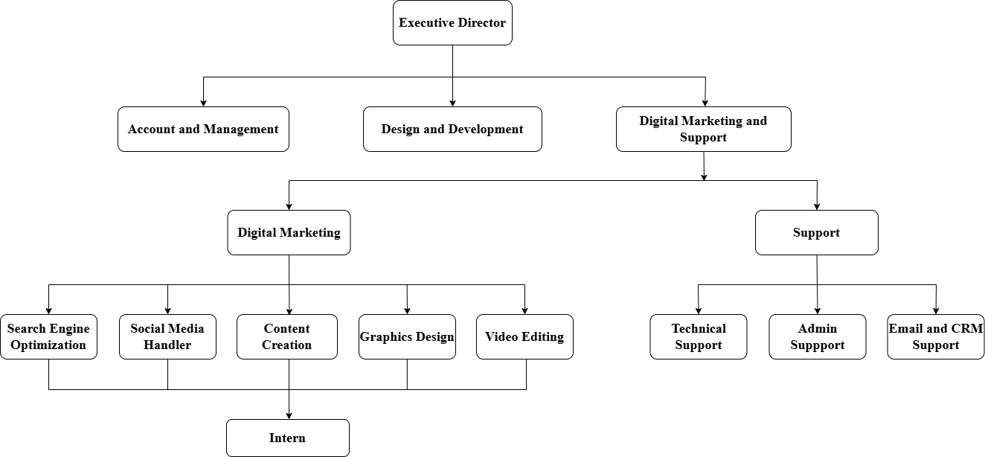

Fig 2.2: Hierarchical Structure of the Organization

Working Domains of Organization
The organization operates across multiple domains to deliver comprehensive and client- focused IT solutions. The key working domains of Passion Chasers are listed below:

Website Development:
Passion Chasers offers expert website development services that emphasize responsive design, smooth functionality, and modern UI/UX principles. Their solutions ensure websites are visually appealing, user-friendly, and optimized for all devices.

Graphic Design:
The company delivers creative graphic design services that align with brand identity and communicate messages effectively. Their designs aim to enhance brand visibility and make a lasting impression in a competitive market.

Laravel Developer:
Passion Chasers provides a full suite of Laravel development services, including web application development, backend system design, API integration, database management, authentication systems, and maintaining and optimizing existing applications. Their solutions combine scalability and efficiency to ensure performance and reliable system growth using Laravel.

SEO Services:
Understanding the value of visibility, Passion Chasers offers tailored local SEO services to help businesses of all sizes improve search engine rankings through on-page optimization, keyword targeting, and performance tracking.

Training:
Passion Chasers values the significance of comprehensive training programs in fostering professional development and enhancing workforce productivity. Through our tailored training solutions, we equip individuals and teams with the necessary skills and knowledge to excel in their roles, driving organizational success and innovation.

Internship Program and Mentorship:
As part of their commitment to nurturing talent and fostering growth in the technology sector, Passion Chasers provides internship opportunities to students from diverse technical backgrounds. They offer hands-on training and mentorship, equipping interns with valuable skills and experiences to prepare them for future career opportunities.

Description of Intern Department
Passion Chasers provides valuable hands-on experience through its internship program, aimed at fostering future professionals in the Laravel Developer space. The application process includes an online submission followed by a face-to-face interview with team leaders for selected candidates. Once accepted, interns are given the same resources and support as full-time employees, including onboarding, skill evaluation, and training.
During my internship at Passion Chasers, I worked closely with a team of experienced Laravel developers, gaining exposure to various aspects of the field. My responsibilities included backend development, database management, API integration, debugging, and maintaining web applications. I was treated as a full-time employee, and the company’s six-day workweek provided a structured yet dynamic environment for learning and growth. Passion Chasers fosters a culture of collaboration, allowing interns to contribute meaningfully while gaining insights into real-world Laravel development practices using Laravel.

Chapter 3: Background Study and Literature Review

Background Study
Passion Chasers, a dynamic and growing IT company based in Biratnagar, has carved a niche in the digital services space through its innovative and client-centric approach. Established on November 30, 2023, the company specializes in various domains including website and mobile application development, integrated management systems, graphic design, and Laravel Developer. Among these, Laravel Developer has emerged as one of its core services, where Passion Chasers excels by blending creative strategies with data- driven solutions. As part of its talent development initiative, the company offers internship opportunities for aspiring digital marketers to gain real-world experience.
The Laravel Developer Department at Passion Chasers plays a vital role in designing, developing, and maintaining secure and scalable web applications for clients. This department focuses on a wide range of services including backend development, REST API development, database design and management, authentication and authorization systems, integration of third-party services, bug fixing, performance optimization, and deployment support. The team works in a collaborative environment where clean coding practices meet modern development standards to deliver efficient and customized solutions. Interns are integrated into this development ecosystem and trained to contribute meaningfully by working on real projects under expert supervision. The program ensures that each intern understands and applies core Laravel concepts while exploring the latest trends and best practices in web development.
My internship at Passion Chasers was focused on Laravel Development, where I worked alongside a team of experienced developers. I was actively involved in developing and managing backend modules, working with Laravel MVC architecture, handling CRUD operations, database migrations, and integrating APIs to support system functionality. In addition, I participated in debugging and improving existing features, optimizing application performance, and ensuring proper validation and security practices. This hands-on experience helped me strengthen my programming and problem-solving skills while also exposing me to industry-standard tools and development workflows. The company’s structured work environment and supportive culture provided the ideal space for learning and professional growth. Through this internship, I gained a solid foundation in Laravel development practices and real-world insight into how well-structured web applications contribute to business efficiency and success.

Literature Review

Laravel Framework and Web Application Development by Taylor
(Taylor, 2018) emphasizes the importance of Laravel as a modern PHP framework in building secure and scalable web applications. The study explains that Laravel simplifies development through features like MVC architecture, routing, authentication, and built-in security mechanisms. Laravel promotes clean and maintainable code, which improves long-term project efficiency. It also highlights how Laravel supports rapid application development using reusable components and packages. The framework enhances developer productivity and reduces development time. Overall, Laravel is shown to be highly effective in creating professional and high-performing web systems.

Database Management and Optimization in Laravel Applications by Kumar
(Kumar, 2019) explains how efficient database management improves Laravel application performance and reliability. The study highlights the role of migrations, seeders, and Eloquent ORM in managing structured database operations. Proper indexing, query optimization, and relationship handling help reduce system load and improve response time. The research stresses the importance of designing normalized databases and implementing efficient CRUD functionality. Database optimization also supports scalability in large applications. Overall, effective database management ensures smoother application functionality and better user experience.

API Integration and Backend Development in Laravel by Kapoor
(Kapoor, 2020) explores how Laravel supports backend development and API integration for modern web applications. The study discusses the importance of RESTful APIs in connecting frontend systems with backend services. Laravel provides tools such as API resources, middleware, and authentication systems like Passport and Sanctum to secure API access. The research highlights how API integration improves system automation and enables third-party service connectivity. It also emphasizes the need for proper validation and error handling for stable application performance. Overall, API-based development is identified as essential for building flexible and scalable Laravel systems.

Security Practices in Laravel Web Applications by Ryan
(Ryan, 2021) highlights the significance of implementing strong security measures in Laravel-based web applications. The study explains that Laravel provides built-in security features such as CSRF protection, password hashing, validation, and authentication. It emphasizes the importance of preventing vulnerabilities like SQL injection, XSS, and unauthorized access. Secure session handling and role-based access control enhance system safety. The research also shows that regular updates and secure coding practices improve application reliability. Overall, Laravel security practices strengthen user trust and protect sensitive data in web systems.
Summary of Literature Review

S.N | Literature Review | Description
1. | Laravel Framework and Web Application Development by Taylor | • Highlights how Laravel supports secure and scalable web application development.  • Emphasizes MVC architecture, routing, and authentication for efficient development.
2. |  | • Shows how migrations, Eloquent ORM, and query optimization improve database performance.  • Notes that proper database design enhances scalability and reliability.
  Database Management and
  Optimization in Laravel
  Applications by Kumar
3. |  | • Focuses on RESTful API development and backend integration for modern systems.  • Highlights middleware, validation, and authentication for secure API access.
  API Integration and Backend
  Development in Laravel by Kapoor
4. | Security Practices in Laravel Web Applications by Ryan | • Highlights Laravel’s built-in security features such as CSRF protection and password hashing.  • Emphasizes preventing SQL injection, XSS, and unauthorized access through secure coding.

Chapter 4: Internship Activities

Roles and Responsibilities
As a Laravel Developer Intern, my primary role involved assisting in the development and maintenance of web applications using the Laravel framework. I contributed to backend development, database management, API integration, and debugging tasks to support ongoing client projects. My main goal was to enhance system functionality, ensure smooth performance, and support the development team by implementing efficient and scalable solutions.
Key responsibilities of my internship include:
Backend Development:
I was responsible for developing and maintaining backend modules using Laravel MVC architecture. This included implementing CRUD operations, managing controllers, models, and views, and ensuring proper validation of user input. I also worked on improving application functionality based on project requirements.
Database Management:
I assisted in designing and managing databases using MySQL. This included creating migrations, seeders, and database relationships using Eloquent ORM. I ensured that data was stored and retrieved efficiently to support smooth system performance.
API Integration:
I worked on integrating RESTful APIs for connecting the backend with external services and frontend systems. This included testing API responses, handling authentication, and ensuring proper request and response formatting for system reliability.
Bug Fixing and Optimization:
I supported the team by identifying and fixing bugs in existing modules. I also worked on optimizing code performance by improving query efficiency and ensuring proper error handling to enhance application stability.
Collaboration with Development Team:
I worked closely with senior developers and team members to ensure that application features were aligned with client requirements. This collaboration provided valuable insights into professional software development workflows, coding standards, and project coordination.

Weekly Log (Technical Details of Activities)

Weekly Log Report

Name: Shibu Sharma
Project: Company Onboarding & Laravel Developer Initiatives
Week No.: 1 Date: 2082/10/18

Responsibilities:
- Learn and understand basic SEO concepts.
- Assist in content creation and poster design.
- Collaborate with the design team for social media posts.

Activities and Observations:
- Learned SEO basics and keyword structure.
- Designed the Saraswati Puja poster using Canva and Figma.
- Participated in team discussions for creative ideas.

Observation:
Gained a better understanding of SEO fundamentals and the connection between keyword structure and effective content ranking.

Plan for Next Week:
- Design branding materials like letter pads and company templates.

Performance Appraisal by Mentors:
Satisfactory
Quick learner and shows creativity in design tasks.

Supervisor’s Approval Mentor’s Approval
Name : Kushal Niroula Name : Jivan Niraula
Signature : Signature :

Weekly Log Report

Name: Shibu Sharma
Project: Company Onboarding & Design Enhancement
Week No.: 2 Date: 2082/10/26

Responsibilities:
- Designed company branding materials.
- Conduct research on digital marketing packages.
- Collaborate with teammates for idea validation.

Activities and Observations:
- Designed MS Word letter pad and email templates.
- Conducted research on standard monthly marketing packages.
- Collaborated with team members for design validation.

Observation:
Learned the importance of maintaining brand consistency while designing

Plan for Next Week:
- Finalize digital marketing packages and create related designs.

Performance Appraisal by Mentors:
Excellent
Very attentive to detail; contributes practical research and design input.

Supervisor’s Approval Mentor’s Approval
Name : Kushal Niroula Name : Jivan Niraula
Signature : Signature :

Weekly Log Report

Name: Shibu Sharma
Project: Laravel Developer Package Design & Branding
Week No.: 3 Date: 2082/11/04

Responsibilities:
- Finalize and document digital marketing packages.
- Design festival posters for social platforms.
- Learn creative ad content structuring.

Activities and Observations:
- Finalized monthly digital marketing packages.
- Created Gyalpo Loshar festival poster.
- Designed content layout for promotional material.

Observation:
Developed a deeper understanding of festive branding requirements and how to convey the right message through design elements.

Plan for Next Week:
- Create promotional videos and begin work on certificate design.

Performance Appraisal by Mentors:
Excellent
Consistent performance and noticeable creative growth throughout the week. Communicates effectively with the team and contributes ideas that align well with
the project goals.

Supervisor’s Approval Mentor’s Approval
Name : Kushal Niroula Name : Jivan Niraula
Signature : Signature :

Weekly Log Report

Name: Shibu Sharma
Project: HDC Event Certificate Design & Social Media Engagement
Week No.: 4 Date: 2082/11/11

Responsibilities:
- Create promotional content (video and posters).
- Design certificates for company events.
- Assist in branding materials for events.

Activities and Observations:
- Created promotional video for digital marketing services.
- Designed certificates for Chef Competition.
- Contributed to event branding efforts.

Observation:
Learned the process of creating engaging promotional videos, understanding the balance of animation timing and visual appeal.

Plan for Next Week:
- Design Holi posters and continue with certificate tasks.

Performance Appraisal by Mentors:
Excellent
Brings innovative video ideas to the table with a strong sense of responsibility and accuracy.

Supervisor’s Approval Mentor’s Approval
Name : Kushal Niroula Name : Jivan Niraula
Signature : Signature :

Weekly Log Report

Name: Shibu Sharma
Project: Certificate & Poster Design for HDC
Week No.: 5 Date: 2082/11/18

Responsibilities:
- Design certificates and event posters.
- Learn and apply on-page SEO techniques.
- Coordinate with the marketing team.

Activities and Observations:
- Designed Holi posters and new certificates.
- Continued SEO learning sessions.
- Collaborated on project assignments with the team.

Observation:
Learned how SEO can be practically applied to content for better visibility and how different types of branding materials require unique design

Plan for Next Week:
- Apply SEO techniques to the company website and start UI/UX design.

Performance Appraisal by Mentors:
Excellent
Proactive learner with multitasking skills and a strong work ethic.

Supervisor’s Approval Mentor’s Approval
Name : Kushal Niroula Name : Jivan Niraula
Signature : Signature :

Weekly Log Report

Name: Shibu Sharma
Project: SEO and Figma-based Finance Dashboard(UI/UX Design)
Week No.: 6 Date: 2082/11/25

Responsibilities:
- Contribute to on-page SEO improvement.
- Design a finance dashboard using Figma.
- Apply UI/UX design best practices.

Activities and Observations:
- Researched and documented SEO best practices for internal pages.
- Designed UI for a finance dashboard in Figma.
- Studied color psychology to improve dashboard color schemes.

Observation:
Gained clarity on how visual hierarchy and color schemes impact user decision-making, especially in data-heavy interfaces.

Plan for Next Week:
- Start designing mobile UI for a real estate app.

Performance Appraisal by Mentors:
Excellent
Consistent growth in UI/UX expertise along with a highly efficient and professional attitude.

Supervisor’s Approval Mentor’s Approval
Name : Kushal Niroula Name : Jivan Niraula
Signature : Signature :

Weekly Log Report

Name: Shibu Sharma
Project: Real Estate Mobile Application – UI/UX Design
Week No.: 7 Date: 2082/12/05

Responsibilities:
- Design mobile UI for real estate app.
- Gather and incorporate feedback.
- Implement mobile-friendly UX components.

Activities and Observations:
- Designed screens for a real estate mobile.
- Implemented animations and property filters.
- Collected and applied feedback from mentors.

Observation:
Refined mobile UI skills and learned how iterative design based on feedback improves aesthetics and functionality.

Plan for Next Week:
- Work on video editing for Changing Nepal and design internship certificate.

Performance Appraisal by Mentors:
Good
Strong creative instincts and attention to mobile UI details. Also needs to focus more on enhancing overall UX flow and user journey.

Supervisor’s Approval Mentor’s Approval
Name : Kushal Niroula Name : Jivan Niraula
Signature : Signature :

Weekly Log Report

Name: Shibu Sharma
Project: Changing Nepal – Media & Design Contribution
Week No.: 8 Date: 2082/12/27

Responsibilities:
- Create promotional video content.
- Design certificates for company events.
- Assist in branding materials for events.

Activities and Observations:
- Edited promotional video content for external clients.
- Designed internship certificates for ongoing.
- Helped in creating visual assets for upcoming campaigns.

Observation:
Understood how transitions and timing impact voiceovers in videos, and how visual branding plays a role in both internal and customer-facing

Plan for Next Week:
- Meeting with mentors to discuss branding strategies and gather feedback.

Performance Appraisal by Mentors:
Great Consistency
Delivers clean and visual appealing content. Keeps improving with each project.

Supervisor’s Approval Mentor’s Approval
Name : Kushal Niroula Name : Jivan Niraula
Signature : Signature :

Description of the Project Involved During Internship
During my internship at Passion Chasers, I actively contributed to a range of Laravel development activities aimed at improving the performance, functionality, and reliability of web-based systems. My responsibilities included assisting in backend development, implementing database operations, and supporting the development team in building dynamic and scalable web applications using the Laravel framework. I worked on developing and maintaining system modules by applying Laravel MVC architecture, routing, middleware, and validation to ensure smooth application workflow and secure user interaction.
I was involved in managing databases through MySQL, including creating and updating tables using migrations, handling relationships using Eloquent ORM, and ensuring efficient data retrieval through optimized queries. Additionally, I assisted in integrating APIs and testing application responses to ensure proper communication between frontend and backend systems. I also participated in debugging and resolving errors, improving existing features, and enhancing overall system performance.
Furthermore, I contributed to UI-related improvements by supporting the team in adjusting layouts and improving user flow for ongoing projects. This included working with development tools and collaborating with senior developers to understand best coding practices, version control, and real-world project handling. Throughout the internship, I worked closely with the team to align application development with client requirements, deepening my understanding of how structured backend development, database management, and system optimization contribute to building efficient and user-friendly web applications.

Task/Activities Performed
During my internship at Passion Chasers as a Laravel Developer Intern, I was involved in a variety of technical tasks that contributed to the development, improvement, and maintenance of web-based applications. These activities included:
- Assisted in developing and maintaining backend modules using the Laravel framework based on MVC architecture.
- Performed CRUD operations and implemented form handling with proper validation to ensure accurate data processing.
- Worked with MySQL databases, including creating migrations, managing relationships, and optimizing queries using Eloquent ORM.
- Supported the integration and testing of RESTful APIs to ensure smooth communication between frontend and backend systems.
- Participated in debugging and fixing application issues to improve system performance and functionality.
- Collaborated on UI-related improvements by assisting in layout adjustments and improving user flow based on project requirements.
- Worked closely with senior developers and team members to align development tasks with project goals and ensure proper implementation of features.

Chapter 5: Conclusion and Learning Outcomes

Conclusion
After completing my internship as a Laravel Developer Intern at Passion Chasers, I gained valuable practical experience in developing and maintaining web applications using the Laravel framework. I strengthened my understanding of backend development concepts such as MVC architecture, routing, middleware, authentication, and form validation. I also improved my skills in database management by working with MySQL, creating migrations, handling relationships using Eloquent ORM, and performing efficient CRUD operations.
Through hands-on project involvement, I became familiar with real-world development workflows, debugging techniques, and code optimization practices. This internship also helped me understand the importance of writing clean, secure, and maintainable code while ensuring smooth application performance. Additionally, I gained experience collaborating with senior developers and team members, which improved my communication and teamwork abilities in a professional environment.
Overall, the internship provided me with a strong foundation in Laravel development practices and enhanced my confidence in building functional and scalable web applications. It also prepared me for future opportunities in the software development field by giving me real-world exposure to professional development standards and project-based learning.

Learning Outcomes
During my internship as a Laravel Developer Intern at Passion Chasers, I attained several key learning outcomes that will shape my future career. These include:
- Gained a comprehensive understanding of Laravel development concepts, including MVC architecture, routing, middleware, authentication, and validation.
- Acquired hands-on experience in developing web application modules using Laravel, including implementing CRUD operations and managing application logic.
- Enhanced my skills in database management by working with MySQL, creating migrations, handling relationships, and using Eloquent ORM for efficient data operations.
- Developed a strong understanding of RESTful API integration, including API testing, handling requests and responses, and ensuring secure communication between systems.
- Improved my ability to identify and fix errors through debugging and troubleshooting, contributing to better system stability and performance.
- Learned the importance of writing clean, structured, and maintainable code by following professional development practices.
- Fostered collaboration and teamwork by working closely with senior developers and team members, learning to adapt quickly and contribute effectively in a fast-paced development environment.

References
Kapoor, A. G. (2020). API integration and backend development in Laravel. Journal of Web Development Studies, 45–49. https://doi.org/10.1016/j.jdm.2020.04.009
Kumar, A. (2019). Database management and optimization in Laravel applications. International Journal of Software Engineering and Technology, 120. https://doi.org/10.21863/ijmt/2019.0902
Ryan, D. (2021). Security practices in Laravel web applications: Strategies for secure and scalable development. Kogan Page. https://doi.org/10.1016/j.jadm.2021.06.004
Taylor, O. (2018). Laravel framework and web application development. Journal of Web Application Research. https://doi.org/10.1109/jmr.2018.07.012
Chatterjee, P. (2021). Laravel development practices and their influence on application performance. Journal of Laravel Development Research, 23.

Appendices

