2018
Clean Energy Nepal
26th April, 2018
Event Proceedings
Earth Day 2018: End Plastic Pollution
21st and 22nd April, 2018

Table of Contents
1. Background 2
2. Objective 2
3. Program Participants 2
4. Activities 3
4.1 ‘Pledge against Plastic’, Photography Competition and Exhibition 3
4.2 Flash Mob and Silent Drama 4
5. Conclusion and Way Forward 4
6. Annexes 5
Annex1: Media Coverage 5
Annex 2: Photo Gallery 7

1. Background
Plastics with their profound use and benefits have become impossible to avoid. Excessive use and abuse of plastic has created a global havoc not just demeaning the aesthetic value of the urban and non-urban places, but also threatening lives and the life support systems of the Earth. Nepal is not an exception to this ever-growing bane of the modern lifestyle. In this context, this year’s Earth Day on 22 April was dedicated to ending plastic pollution, a theme that is relevant all over the world including Nepal.
People in urban areas of Nepal have undoubtedly access to good education, but the misuse and abuse of plastics have led to the enormous problem of plastic pollution. This mismatch between the two indicators of sustainable development – education and environmental wellbeing force one to conclude that the level of awareness regarding the use of plastic fails to improve. Among many actions that need to be taken immediately is the prioritized awareness at the household level ,encouraging judicious use of plastic right from the consumer level.
Thus, Clean Energy Nepal organized the Earth Day celebration program in collaboration with Lalitpur Metropolitan City Ward No. 15, United Nations Development Program and Nepalese Youth for Climate Action (NYCA) on 21 and 22 April 2018.

2. Objective
The main objective of the Earth Day Celebration was to reach out to the mass public and stir awareness on issues of plastic pollution.
- To engage local government and local women’s groups to advocate against the use of plastic from the consumer level.
- To engage youths in witnessing the problem of plastic pollution and also seeking the solutions through photography.
- To discourage single use of plastics and promote recycling, upcycling and alternatives to plastics.

3. Program Participants
Participants from various youth clubs, educational institutions, local government bodies, general public, NGO’s/INGO’s and media participated in the program. The photography exhibition on 21st April, 2018 was attended by around 60 participant, including Mr. Shudarsan Mishra, Ward Chief of Lalitpur Metropolitan City, Ward No. 15 and other elected local representatives of the ward. The program was also attended by several women group members and enterprises working on solid waste management such as Blue Waste to Value and Pu cha Pu. The performance at Civil Mall, Sundhara and Rani Pokhari, Patan on 22nd April, 2018 was witnessed by more than 500 people. Also, the messages from the public on issues of plastic pollution printed on Republica on 22nd April, 2018 reached thousands of readers all over the world.

4. Activities

4.1 ‘Pledge against Plastic’, Photography Competition and Exhibition
Earth Day Celebrations, was started with an open call for photographs on the theme “End Plastic Pollution” was made wherein two photographs from each participant to signify one as problem and another as solution were to be submitted. On 21st April, 2018, a Photograph Exhibition was organized. The program was inaugurated by planting a sapling in the premises of Clean Energy Nepal by Shudarsan Mishra, Ward Chief of Lalitpur Metropolitan City, Ward 15. Rashmi Maharjan, Program Officer,CEN made an opening remark welcoming all distinguished guests and providing the background of Earth Day and Plastic Pollution to the audience. Sanju Shrestha, Network Co-ordinator of NYCA briefed about the month long plantation campaign and highlighted the role of youth to end plastic pollution. Shanti Karanjit, Climate Change Programme Analyst at UNDP Nepal emphasized on the need of consistent efforts to change the attitudes and practices to end plastic pollution in her speech. Ward Chief of Lalitpur Metropolitan City Ward 15 further highlighted the importance of citizen awareness, pressure on governmental bodies and collective efforts to aid the Government in ending plastic pollution. The highlights of the day were Photography Exhibition collected through the online call for participation and demonstration of environment friendly options for recycling and upcycling of plastic. The top three winners of the competition; Mr. Sanjay Kurmi, Ms. Shelu Gurung and Ms. Alisha Maharjan were awarded with the cash prize of Rs. 10,000, 7,500 and 5,000 respectively. Ending with the vote of thanks Mr. Rajan Thapa, Program Manager at CEN expressed that youths need to step up and take charge in the effort to end plastic pollution.
Figure 1: Distinguished guests at the formal program of the Photography Exhibition; from left: Mr. Rajan Thapa, Mr. Shudarsan Mishra, Mrs. Shanti Karanjit Ojha and Mr. Mahendra Manandhar

4.2 Flash Mob and Silent Drama
Continuing with the celebrations on Earth Day i.e. 22nd April, a collection of messages regarding plastic pollution was published on a national daily along with the winning photographs from the exhibition (e.myrepublica.com, 22nd April, 2018). Similarly, CEN volunteers performed flash mob dance and silent drama at Civil Mall in Sundhara and Ranipokhari in Patan. The performances were done to stir up interest and raise awareness about plastic pollution to the general public. Cloth Bags as an alternative to plastic bags were also promoted to the audiences of the performance.
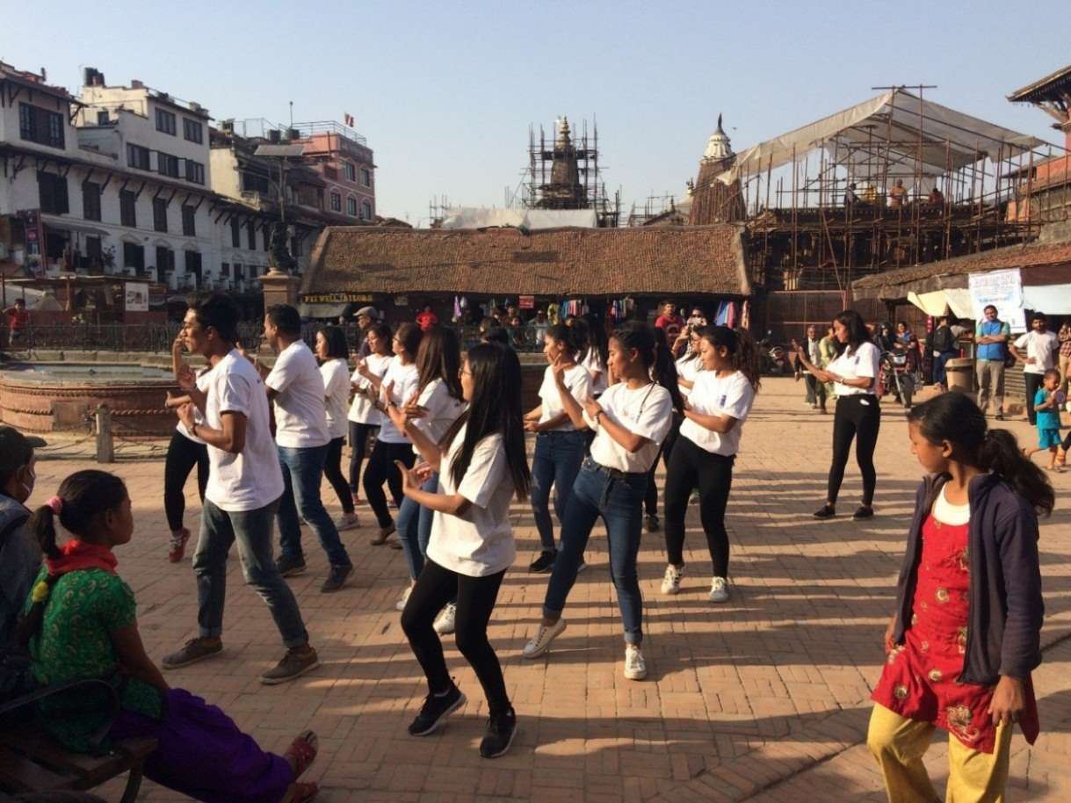
Figure 2: Passer-by observing the flash mob performed by CEN volunteers at Ranipokhari, Patan

5. Conclusion and Way Forward
The Earth Day celebration programs were organized to join the global solidarity in countering the problem of plastic pollution. The program was successful in raising awareness on the urgency to end plastic pollution. It was also successful in reaching out in public with the message to be creative and make positive use of the discarded plastics and also opt for alternatives to plastic. As a way forward, a single day celebration is not enough to bring positive change in the use of plastic culture. Thus, we need to continue our efforts with time, change our attitudes and practices and bring forward a comprehensive action plan to end the global plastic crisis.
The program is an initiation towards increasing the awareness level and bringing behavorial change among users regarding the use of platics. CEN will continue advocating to end the plastic pollution while also marking important days of celebration.

6. Annexes

Annex1: Media Coverage
http://epaper.ekantipur.com/the-kathmandu-post/2018-04-23/1 - Page 3
http://epaper.thehimalayantimes.com/index.php?mod=1&pgnum=2&edcode=71&pagedate=2018-4-23&type= - Page 2
http://nagarikplus.nagariknews.com/epaper/src/epaper.php?id=3399#page/20 - काष्ठमण्डप घ
http://www.janabolinews.com/post/140176/
http://baahrakhari.com/news-details/53782/2018-04-23
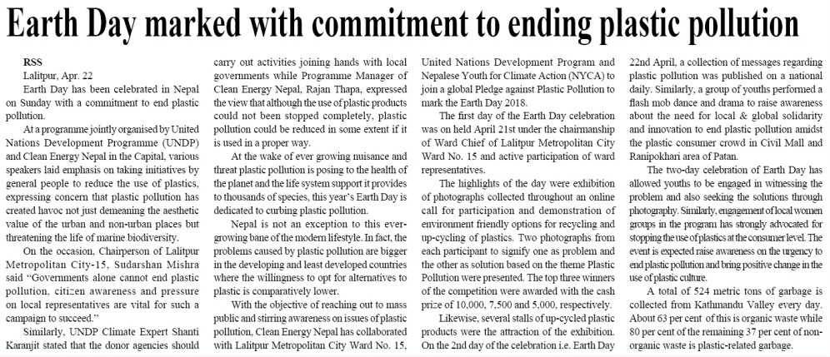
http://tibrakhabar.com/archives/99450
Source: The Rising Nepal, 23rd April, 2018
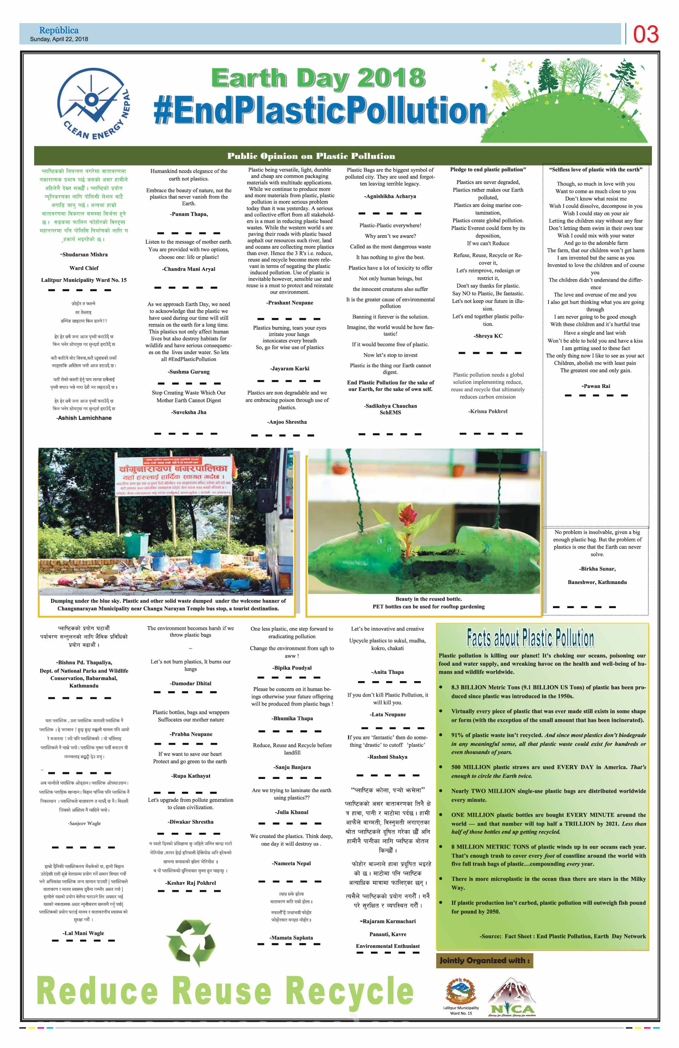
Source: e.myrepublica.com, 22nd April, 2018

Annex 2: Photo Gallery
Figure 3 : Ward Chief of Ward 15 inaugurating the formal program of photography exhibition by planting a sapling at CEN premises
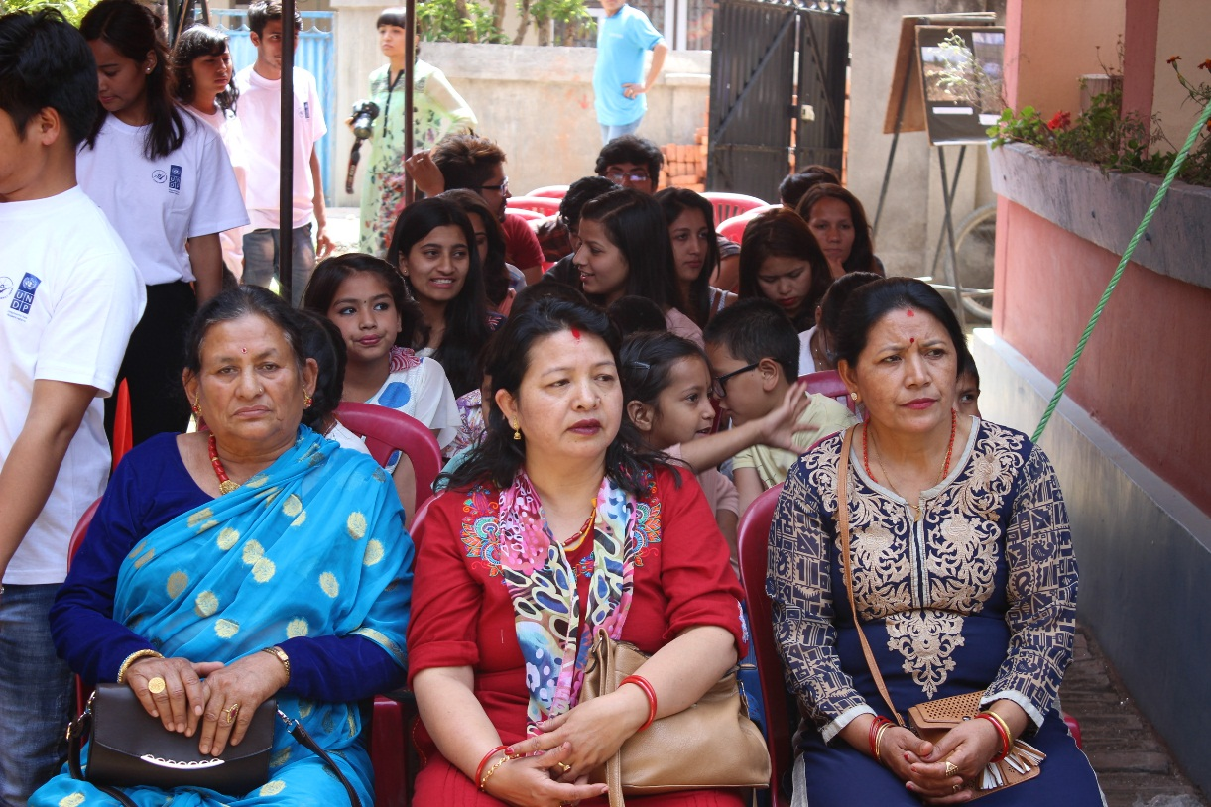
Figure 4: Local representatives of Ward 15, LMC and the audiences observing the program
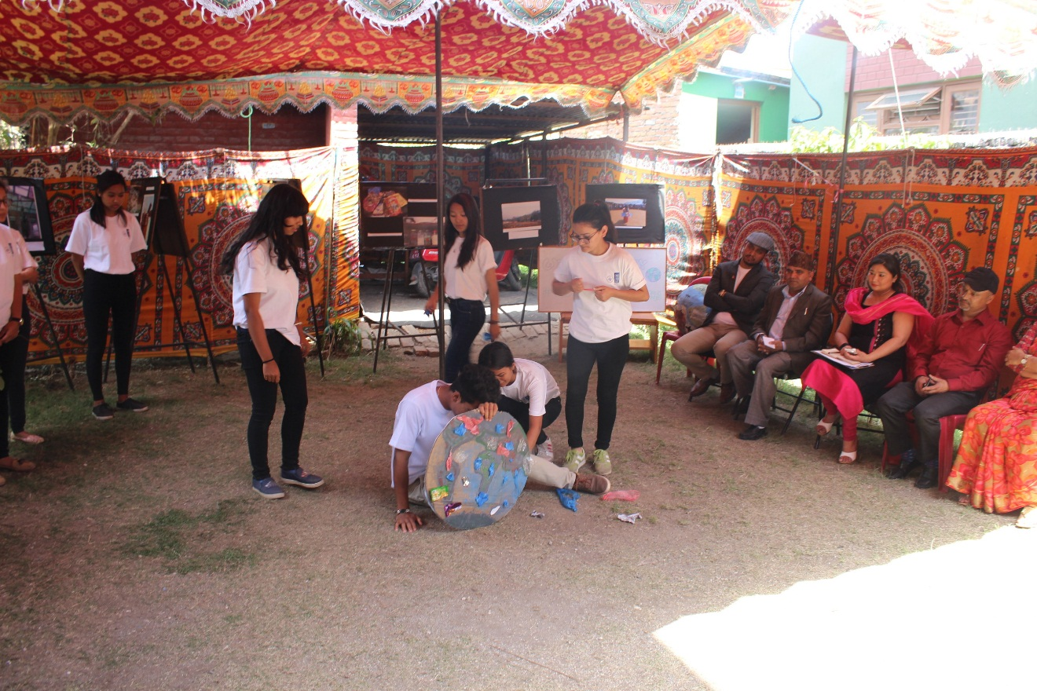
Figure 5: CEN Volunteers performing the silent drama at CEN office
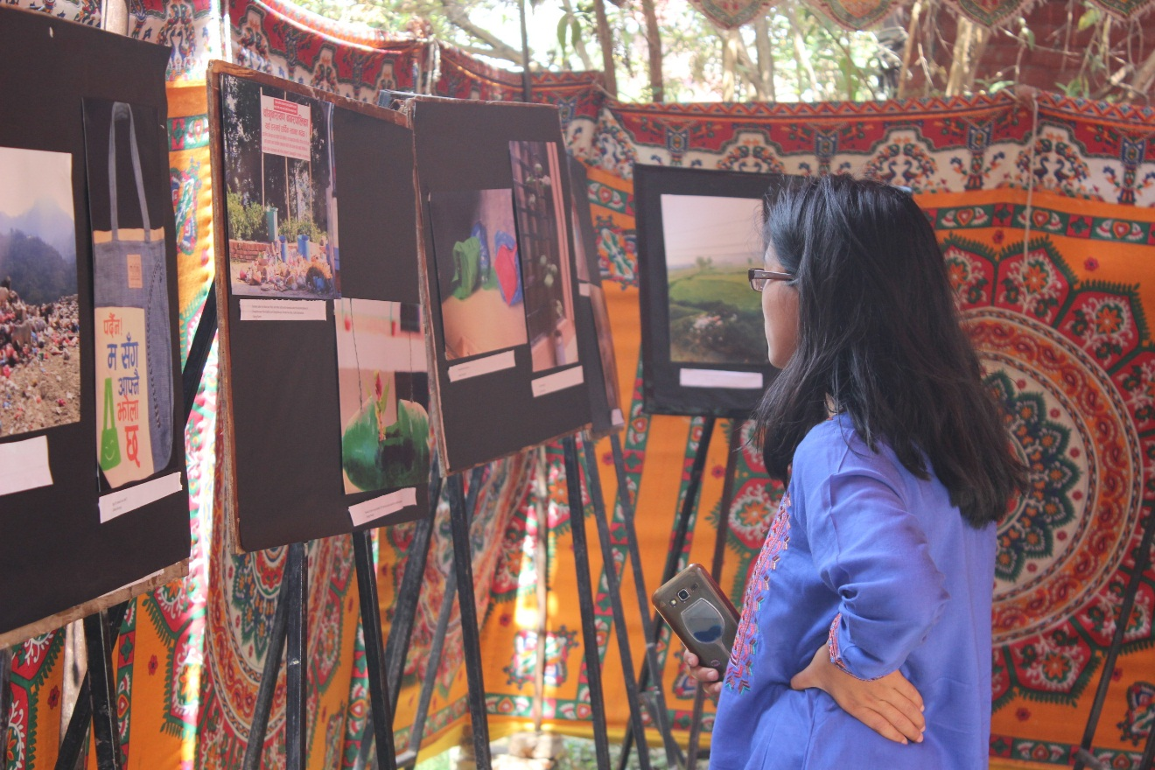
Figure 6: A visitor observing the photographs on display
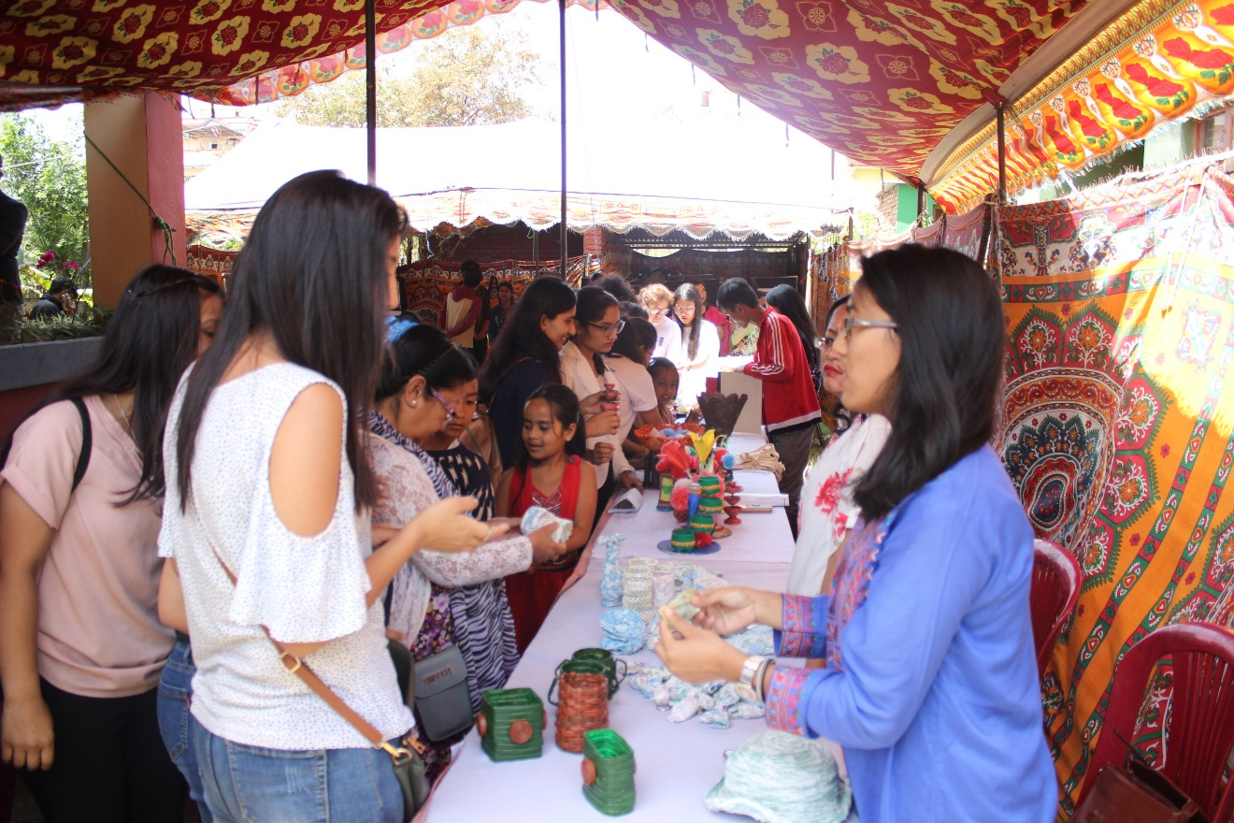
Figure 7: Visitors of the exhibition interacting at the stalls
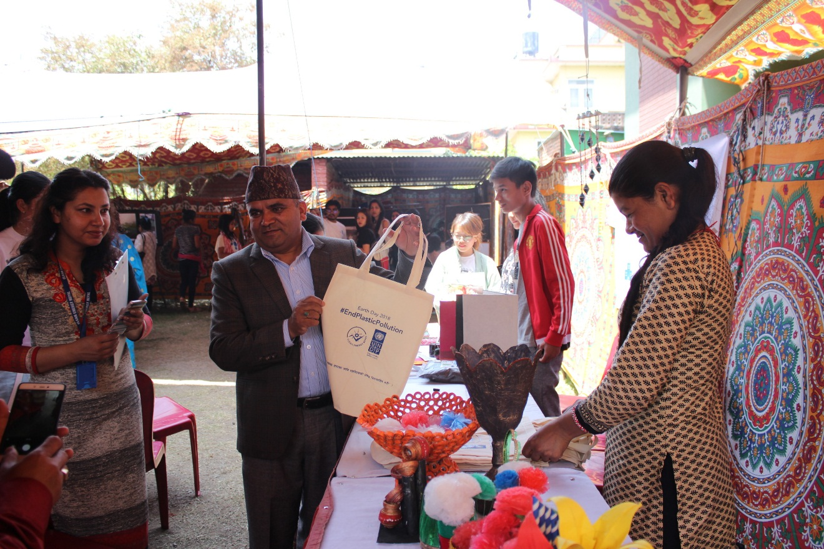
Figure 8: Ward chief posing with the promotional cloth bag as an alternative to plastic bags
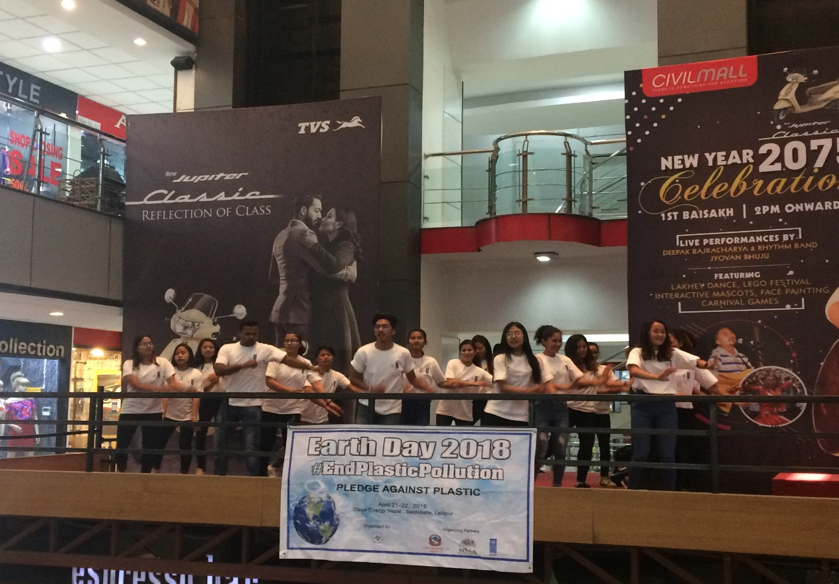
Figure 9: CEN volunteers performing the fash mob at Civil Mall, Sundhara
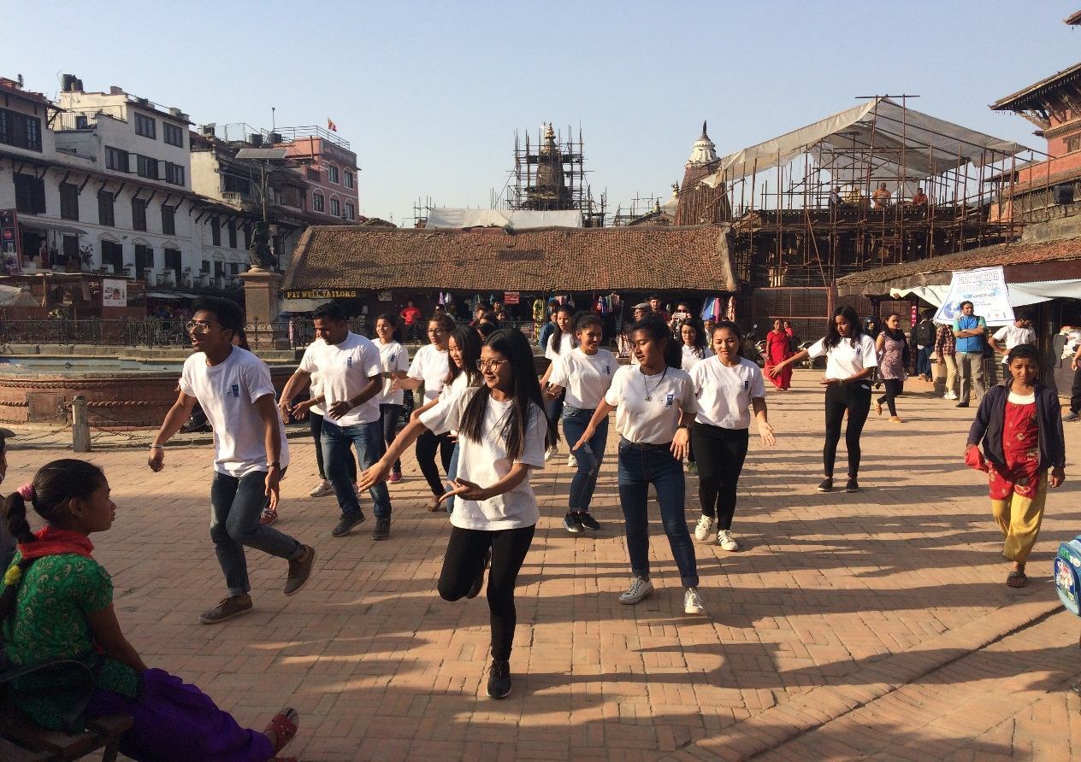
Figure 10: CEN volunteers performing the fash mob at Ranipokhari, Patan

